SPECIFICATION DOCUMENTATION

|  |  |  |  |
| --- | --- | --- | --- |
| Version | Description of change | Author | Date |
| 1 | Initial documentation | **NAME:** Peterson Kamotho  **ADM NO:** SCCI/05868P/2016  **CLASS:**CT | 5th February, 2018 |
|  |  |  |  |
|  |  |  |  |

**Table of Contents**

Overview

1. Project Background and Description

2. Project Scope

3. High-Level Requirements

4. Deliverables

5. Affected Parties

6. Data Flow Diagram(DFD)

7. Use Case Diagram and Use Case analysis

8. Implementation Plan

9. High-Level Timeline/Schedule

10. Approval and Authority to Proceed

iNTERNET BANKING

for: For SME SACCO  
Project Scope

February 5, 2018

# Overview

## Project Background and Description

This is a simple Complete simple Online mobile banking System targeting SMEs that cannot afford a complex mobile banking system. Since it’s an online mobile banking system, all users are created by administrator, Once Registered the users can login and create customers.

This system provides the following facilities:

Balance Enquiry

Funds Transfer to another account in the same bank

Viewing Monthly and annual statements.

## Project Scope

•Customer must have a valid User Id and password to login to the system

• If a wrong password is given thrice in succession that account will be locked and the customer will not be able to use it. When an invalid password is entered a warning is given to the user that his account is going to get locked.

•After the valid user logs in he is shown the list of accounts he has with the bank.

•On selecting the desired account he is taken to a page which shows the present balance in that particular account number

• User can request details of the last ‘n’ number of transactions he has performed.

• User can make a funds transfer to another account in the same bank. User is provided with a transaction password which is different from the login password.

•User can transfer funds from his account to any other account with this bank. If the transaction is successful a notification should appear to the customer, in case it is unsuccessful, and a proper message should be given to the customer as to why it failed.

•User can request for cheque book/change of address/stop payment of cheques.

•User can view his monthly as well as annual statements.

## Purpose and High-Level Requirements

**Purpose:**

This system will be a web based application, that is, any device with internet access and web browser, will be able to access it. In addition, there will be SMS capabilities that can be utilized by any device with SMS capabilities.

This system will have the following capabilities;

* Ability to allow both internal and external users to access the application without downloading any software.
* Ability to interface with the company’s database
* Ability to incorporate automated notifications based on business rules

**High level Requirements:**

HTML: Front End

JSP: Server Side Scripting

DB2: Back End

XHTML: Client Side (JAVA Script)

## Deliverables

* Back-end software that is hosted locally
* UI Prototype for both customers and internal users.
* Management web based application, accessible through specific authorized computers.
* Member’s responsive web based application accessible.
* User documentation manual.
* Technical documentation

## Affected Parties

* SACCO
* Customers

## Data Flow Diagram (DFD)

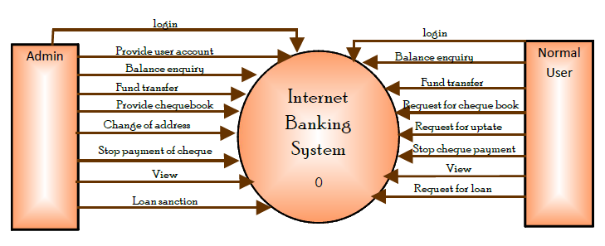

## Use Case Diagram.

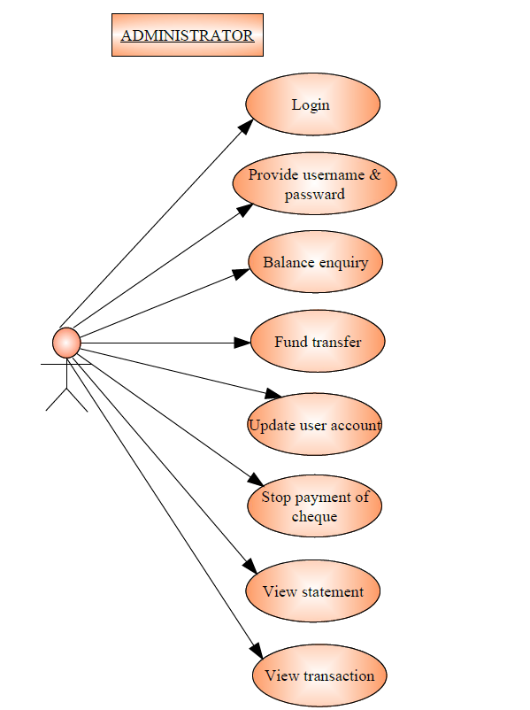

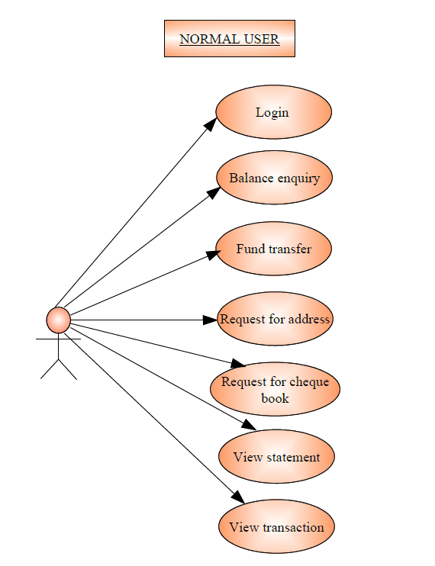

**Use Case Analysis**

**Administrator:**

1. LOGIN: the administrator can log in to the system by giving correct user name and password.
2. PROVIDE NAME AND PASSWORD: the administrator can provide user name and password to the normal users.
3. BALANCE ENQUIRY: The administrator can enquire about users' balance.
4. FUND TRANSFER: The administrator can transfer fund from one account to another in the same bank.
5. ADDRESS CHANGE: The administrator can update stored information of normal users.
6. VIEW STATEMENTS: The administrator can view the monthly and annual statements.
7. VIEW TRANSACTIONS: The administrator can view the last transactions.

**Normal user**

1. LOG IN: The normal users can log in to the system by giving correct username and password provided by the administrator.
2. BALANCE ENQUIRY: The normal users can enquire about his balance.
3. FUND TRANSFER: The normal user can transfer fund from one account to another account in same bank.
4. REQUEST FOR ADDRESS CHANGE: The normal user can request for updating his information in case of any change.
5. VIEW STATEMENTS: The normal users can view the monthly and annual statements.
6. VIEW TRANSACTIONS: The normal users can view the last transactions.

## Implementation Plan

The project will kick off with the implementation of stubs necessary to enable development of the prototype.

After the stubs, the UI prototype will be developed. Once the prototype has been developed, the Admin will go through it and approve of it. This stage is to ensure that all required functionalities have been factored and that the user experience (UX) is excellent.

Email and SMS alerts will be integrated once the system is finished.

Signing off, commissioning and training will follow thereafter.

## High-Level Timeline/Schedule

|  |  |  |  |  |
| --- | --- | --- | --- | --- |
| # | Date | Description | Dep. | Comments |
| 1 | 05/2/2018– 09/2/2018 | Wireframe |  |  |
| 2 |  |  | #1 |  |
| 3 |  |  | #2 |  |
| 4 |  |  | #3 |  |
| 5 |  |  | #4 |  |
| 6 |  |  | #4 |  |

## Approval and Authority to Proceed

We approve the project as described above, and authorize the team to proceed.

|  |  |  |  |
| --- | --- | --- | --- |
| Name | Title | Signature | Date |
| Felix Otieno Okoth | Mr. |  | --/02/2018 |
|  |  |  |  |
|  |  |  |  |